
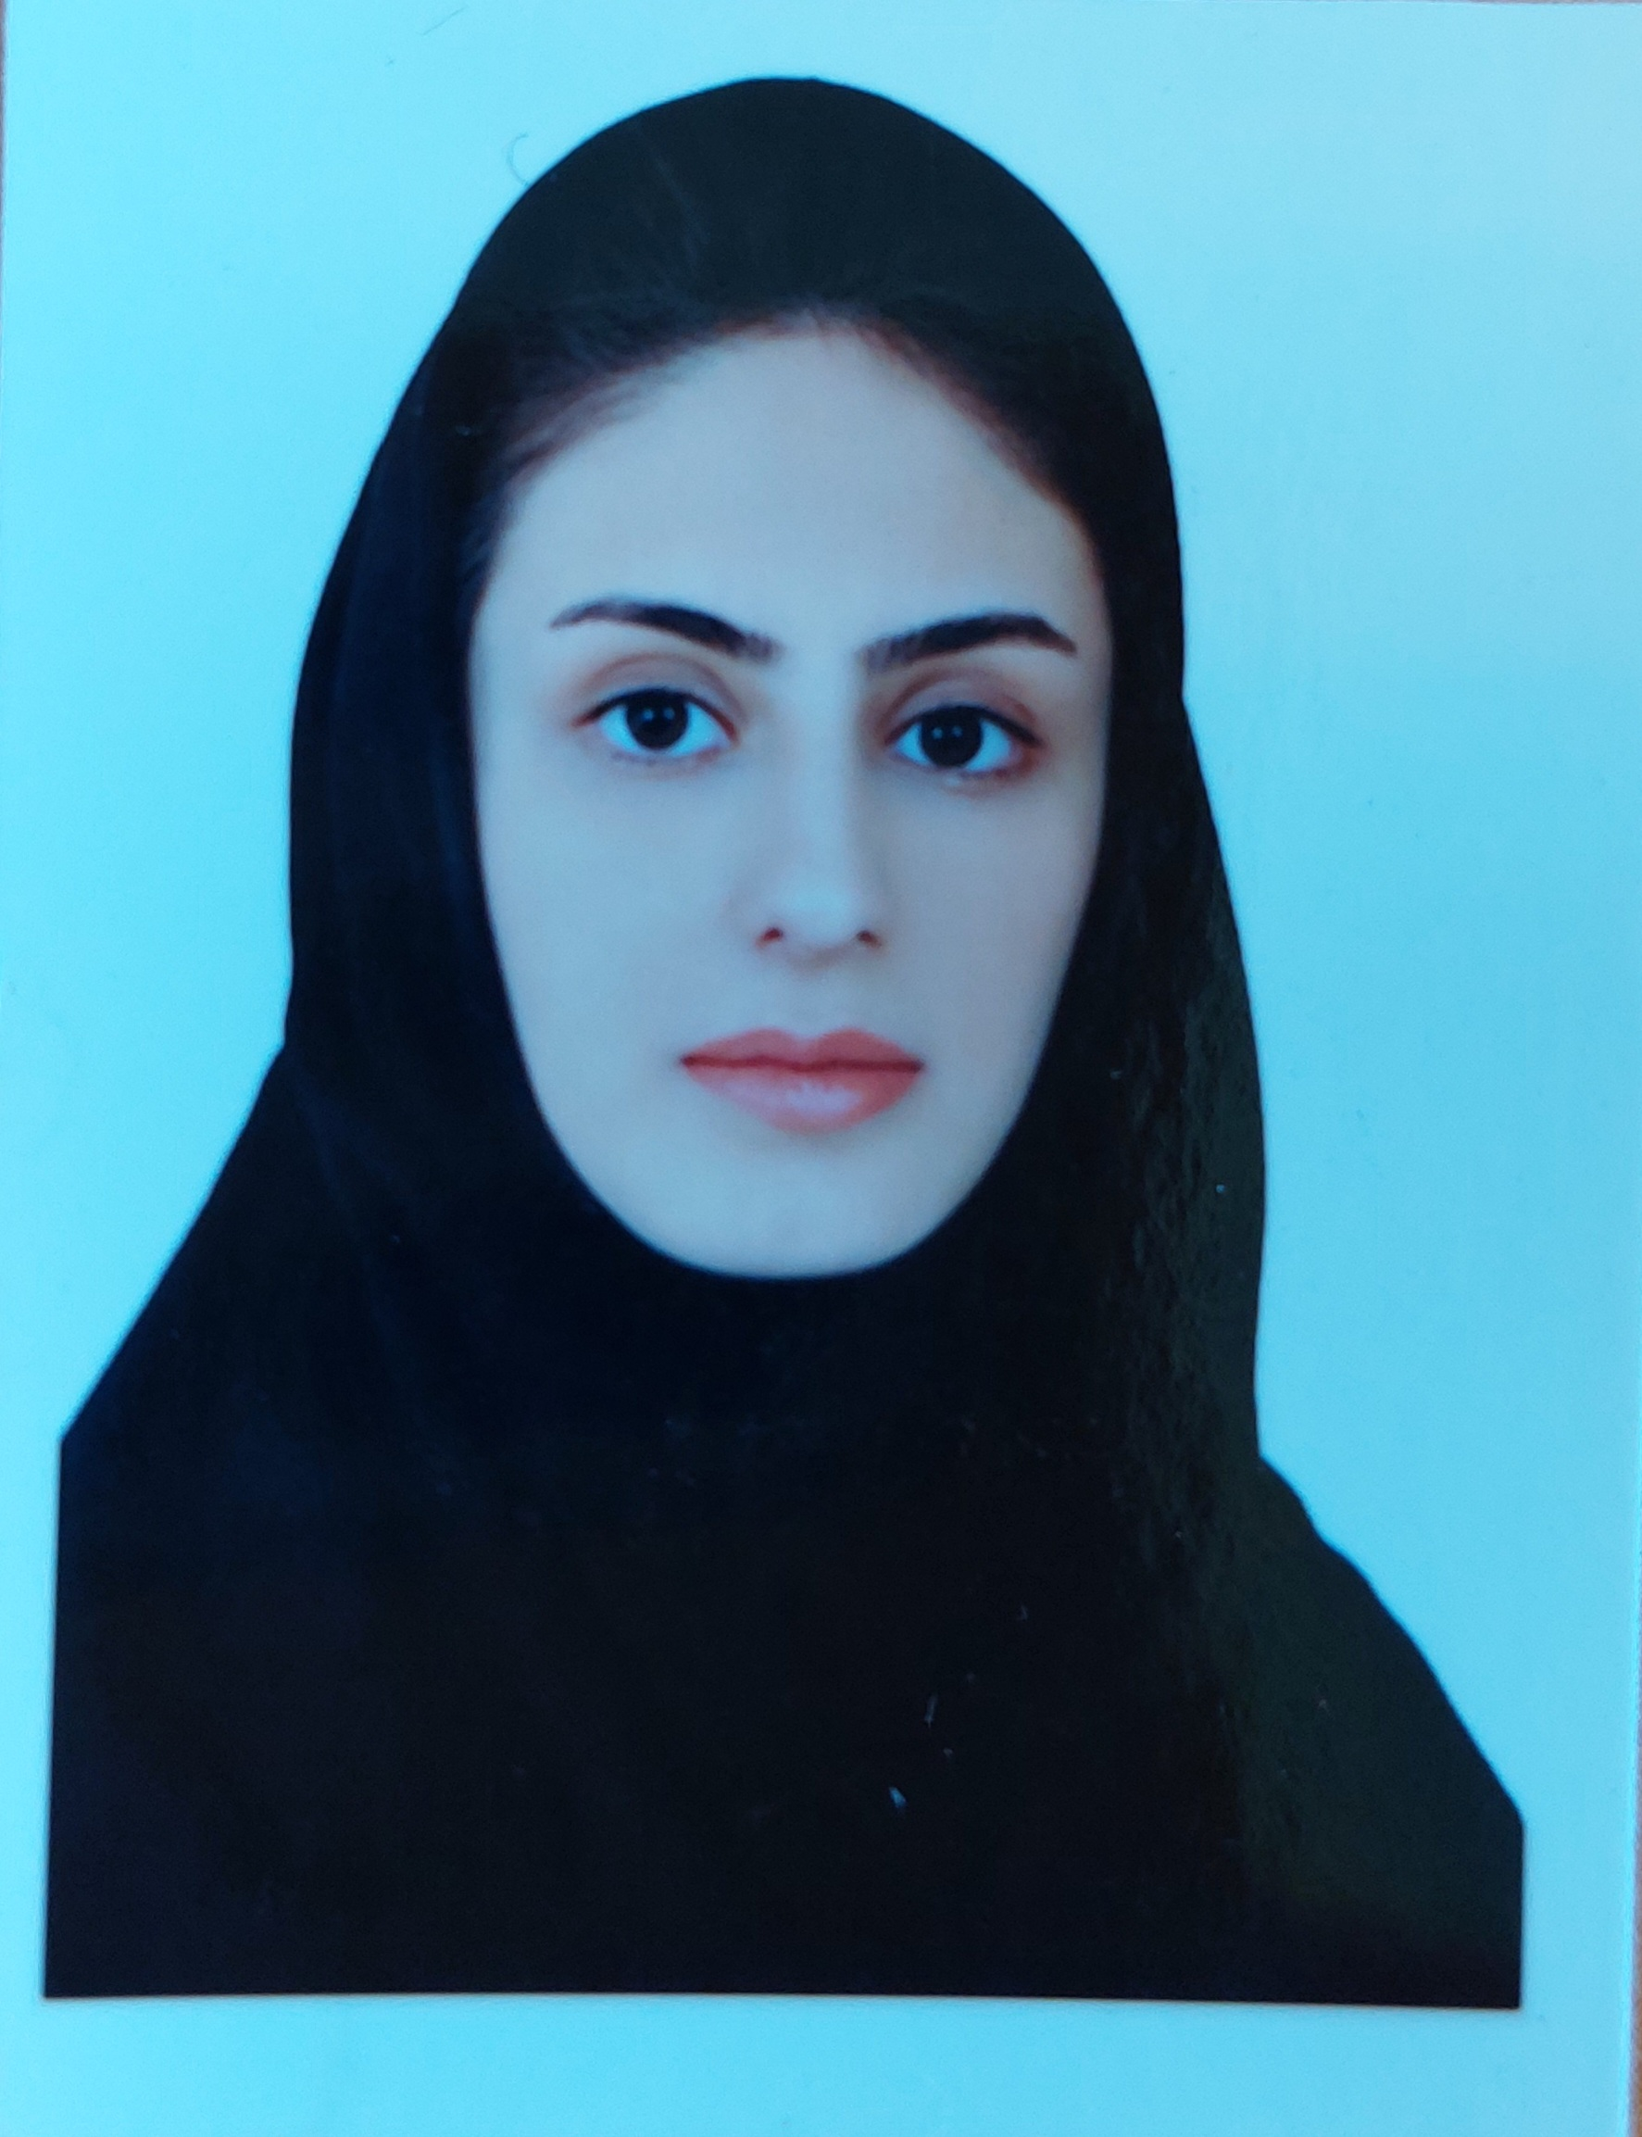

Kurdistan University of Medical Sciences
School of Paramedical Sciences
Name: Negar
Last name: Abdi
Workplace address: Kurdistan - Sanandaj - Pasdaran Boulevard - Kurdistan University of Medical Sciences - School of Paramedical Sciences - Department of Radiology
Scholar: https://scholar.google.com/citations?user=s2Ah-zMAAAAJ&hl=en
Email address: negar.abdi.73@gmail.com
Negar.abdi@muk.ac.ir
Mobile number: 0918-383-7679
Educational background:
Grade | Field of study | University | Year of Entry | Year of Exite
M.Sc | MRI | Isfahan University of Medical Sciences | 2018 | 2020
BSc | Imaging | kurdistan University of Medical Sciences | 2014 | 2018

- Teaching and Working experiences:
Radio technologist, Kowsar Hospital, University of Medical Sciences, Kurdistan, Iran, July 2017 - September 2017.
From October 2020-march 2020 - Islamic Azad University, Sanandaj Branch
Faculty Member of Radiology Department at Kurdistan University of Medical sciences, September 2021 – present.
- Practical teaching ( Name of course):
- Radiology, sonology and electrology in midwifery
- Author and translator of books:
- Workbook radiologic science for technologists
- MRI: techniques and clinical aspects
- MRI quality control tests
- Problems and Solutions in Medical Physics
- Basics of PET Imaging
- Medical Imaging Master MCQs
- Radiography Examination LANGE
- Articles published in scientific journals:
- In vivo study of anti-epidermal growth factor receptor antibody-based iron oxide nanoparticles (anti-EGFR-SPIONs) as a novel MR imaging contrast agent for lung cancer (LLC1) cells detection
- Evaluation of the accuracy of dynamic contrast enhanced MRI in the diagnosis of invasive prostate neoplasm using pathological findings
- Assessment of superparamagnetic iron oxide nanoparticles conjugated with anti-epidermal growth factor receptor antibody for the detection of lung cancer by magnetic resonance imaging (MRI) in C57BL/6
- Optimal b-value in diffusion weighted imaging for detection active multiple sclerosis plaque, using contrast enhancement imaging
- Evaluation of the Relationship between Quantitative Apparent Diffusion Coefficient (ADC) Values in Diffusion-Weighted Images of the Prostate with Glisson Score Values in Pathology Specimens after Prostatectomy
- Neurological manifestation in COVID-19 disease with neuroimaging studies

- History of research activities:
- Optimal b-value in diffusion weighted imaging for detection active multiple sclerosis plaque, using contrast enhancement imaging (cooperator)
- Evaluation of the accuracy of dynamic contrast enhanced MRI in the diagnosis of invasive prostate neoplasm using pathological findings (cooperator)
- Investigating the level of knowledge of doctors in Sanandaj educational centers about the dose of ionizing radiation in relation to the lung CT scan during the outbreak of covid-19

- Participate in conferences inside of the country:
- 33nd Iranian congress of radiology (oral)
- Nanomedicine & Nanosafety 2020 (poster)
- First International Iranian radiology students congress on august 2021

Workshopes:
- Special radiation training course for dental radiography centers in Radiation Research Center of Shiraz University with license number 100102/09/16
- Practical training course of analog and digital periapical device and analog and digital panoramic-cephalometric device
- Examination of mammography and evaluation of images in the Radiology Student Scientific Association
- Ethical principles of working with laboratory animals
- Probing tumor microstructure using diffusion MRI
- Technical and clinical tips for SWI imaging

